v Topic : One Dimensional( 1D ) Array

1.A college administrator stores names of 5 students in a 1D array. Write a program that will ask the user to enter the name of a student and the program will output if the name is in the list of names stored in the 1D array. Use Linear search algorithm.

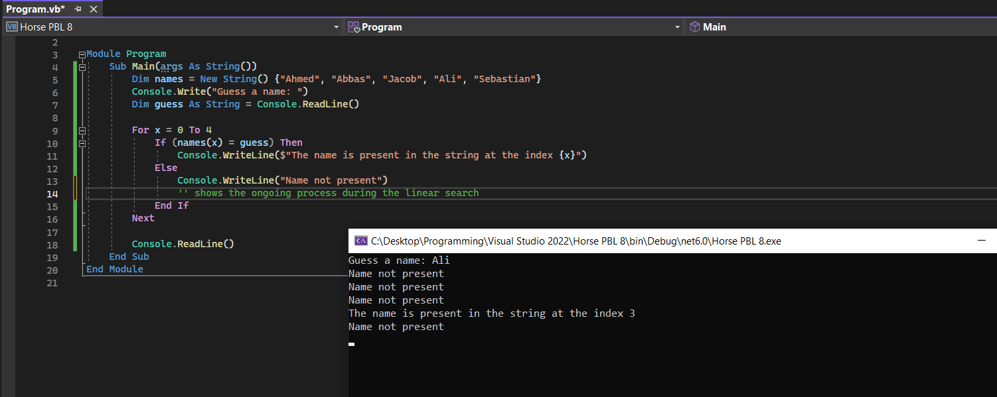

2. A student is developing an algorithm to store number using a 1D array of 100 elements. Each element of the array named Result, contains a REAL value.

The algorithm will output :

* The average value of all the elements
* The number of elements with a value of zero

The structured English description of the algorithm is:

1. SET Total value to 0

2. SET Zero count to 0

3. SELECT the first element

4. ADD value of the element to Total value

5. IF element value is 0 then INCREMENT Zero count

6. REPEAT from step 4 for next element, until element is last element

7. SET Average to Total / 100

8. OUTPUT a suitable message and Average

9 OUTPUT a suitable message and Zero count

**Write program for this algorithm**

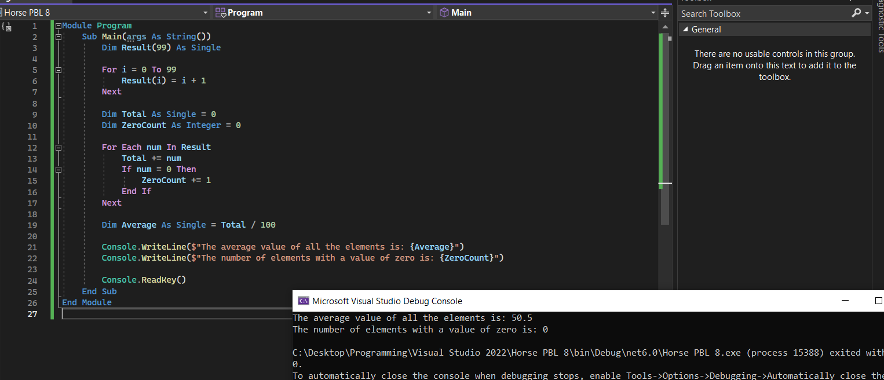

3. Raul writes a program which will tally the number of times each letter in the alphabet appears in a given word input by the user. He uses a 1D array of the size 26 to store the totals for each letter.

Write a program to ask the user to input the word and the program will output the number of times the particular letter of alphabet appears in the word.

